Worksheet 3: Diagram with Equipment¹⁰⁸
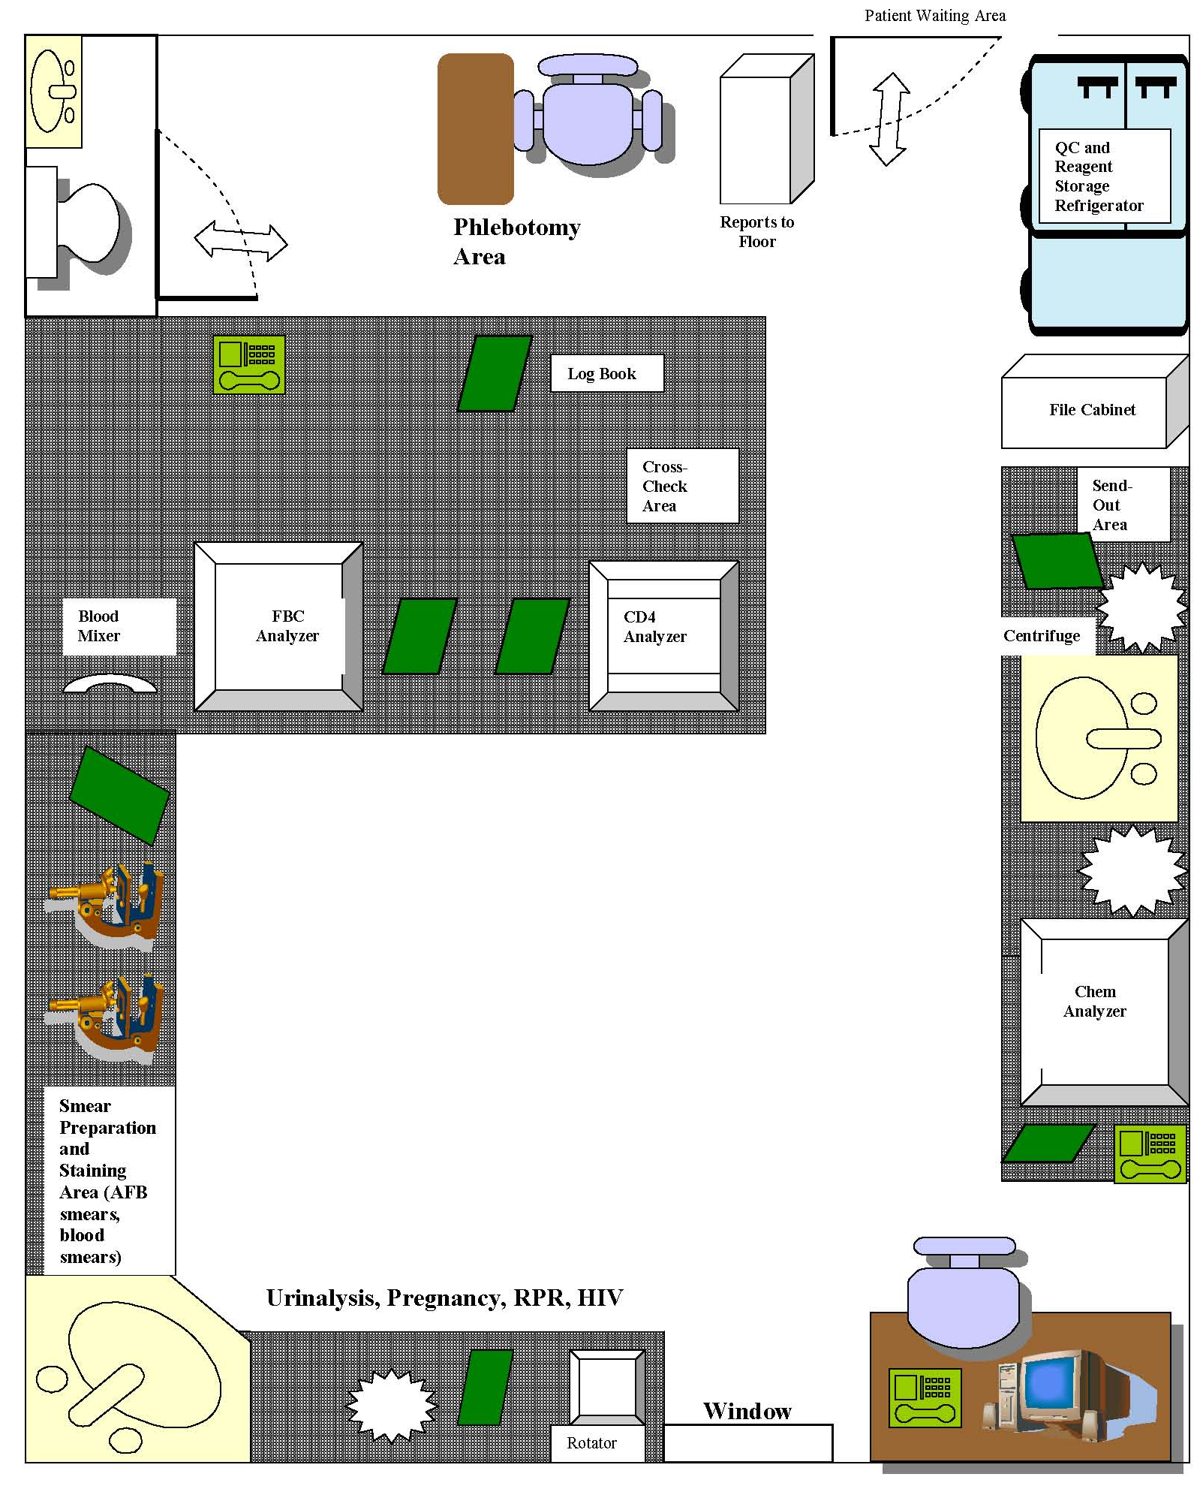
Window with exhaust fan

